ART285: Interactive Audio Design
Lesson 4b: Interactive Song Structure Webpage

In the previous lesson, you selected some of your favorite songs and began designing a visual breakdown of the structure of one of them. In this lesson, you will be taking that visual design and creating an interactive webpage that allows you to hover over and hear the various parts of the song. I know that you all are not web developers, and that this might be your first time working with code, so I provided step by step instructions, as well as videos to take you through the process.

To complete this assignment, you will need Adobe Photoshop and Audition (or a free editing program like GIMP or Audacity). You will also need a code editor, and I recommend VSCode which can be downloaded for free at: https://code.visualstudio.com/

In the lesson 3a videos, I created a poster that used color to highlight different parts of a song, labeled those parts, and add lyrics from the song. I pointed out in the video how to keep the different parts separated, which will be important when we start to divide those sections up.

Video Demo – image asset prep: https://youtu.be/xQQg7_W4dQU
Video Demo – audio asset prep: https://youtu.be/lx285u1z9VU
Video Demo – code prep: https://youtu.be/CWj3gxY1zoo

Asset Preparation
The images and audio that will be used in your website are called assets. Before we can load them into the webpage, we need to prepare them in the correct size and format. The audio assets will be short clips from the song, each a different part of the song structure. The images will also be small sections of the design, that correspond to the audio clips.

Before you start, create a new folder on your computer and name it LASTNAME_285_a4. Then, inside of that folder create two new folders named audio and img.

The audio assets will be created in Audition by opening the song in the program, selecting each section of the song, copying it to a new file, and saving it in the audio folder. You can follow the video listed at the top of this for step-by-step instructions. Name the audio files according to its order and the part of the song. For instance: 1verse.mp3, 2chorus.mp3, 3verse.mp3, 4chorus.mp3, 5break.mp3, 6chorus.mp3, 7bridge.mp3, and 8chorus.mp3. While your song may not have these exact parts, you can use the basic pattern for your names, making sure to not put spaces into the filenames, which will cause the website code to not read the file.

The image assets will be created in Photoshop by cropping each section of the design and saving it as a separate file. You will first save an image of just the waveform and the title of the song. Save it with the name, base.jpg. Make sure to unlock the background layer before you start cropping the different sections of the waveform (see video), and to save the cropped images as pngs. Follow the naming convention as above, for instance: 1verse.png, 2chorus.png, 3verse.png, 4chorus.png, 5break.png, 6chorus.png, 7bridge.png, and 8chorus.png. Again, keep the names consistent between the mp3 and png files, and do not put spaces in the filenames. The video will also demo the saving process.

The demo video and code include 8 parts of the song structure, but your song might have more or less. Even though the code is written for 8 parts, it is easy to delete panels (which contain both the image and the audio) or to add more. I will demo in the video how to add or remove panels. If you are uncertain about your experience with editing the code, or if you have issues with creating any of the assets, please reach out to your instructor.

HTML Code
In the folder with your images and song clips to the img and audio folders, we will be adding an HTML and a CSS file. Create a new website page file by selecting File > New Text File. Then type in the following code and save it as index.html in the website folder. This code will work no matter which song you chose, but you may need to change the filenames highlighted in yellow to match the names of your sound and image files in your folders.

(Your code will appear as one long, scrolling document, not side by side as below).

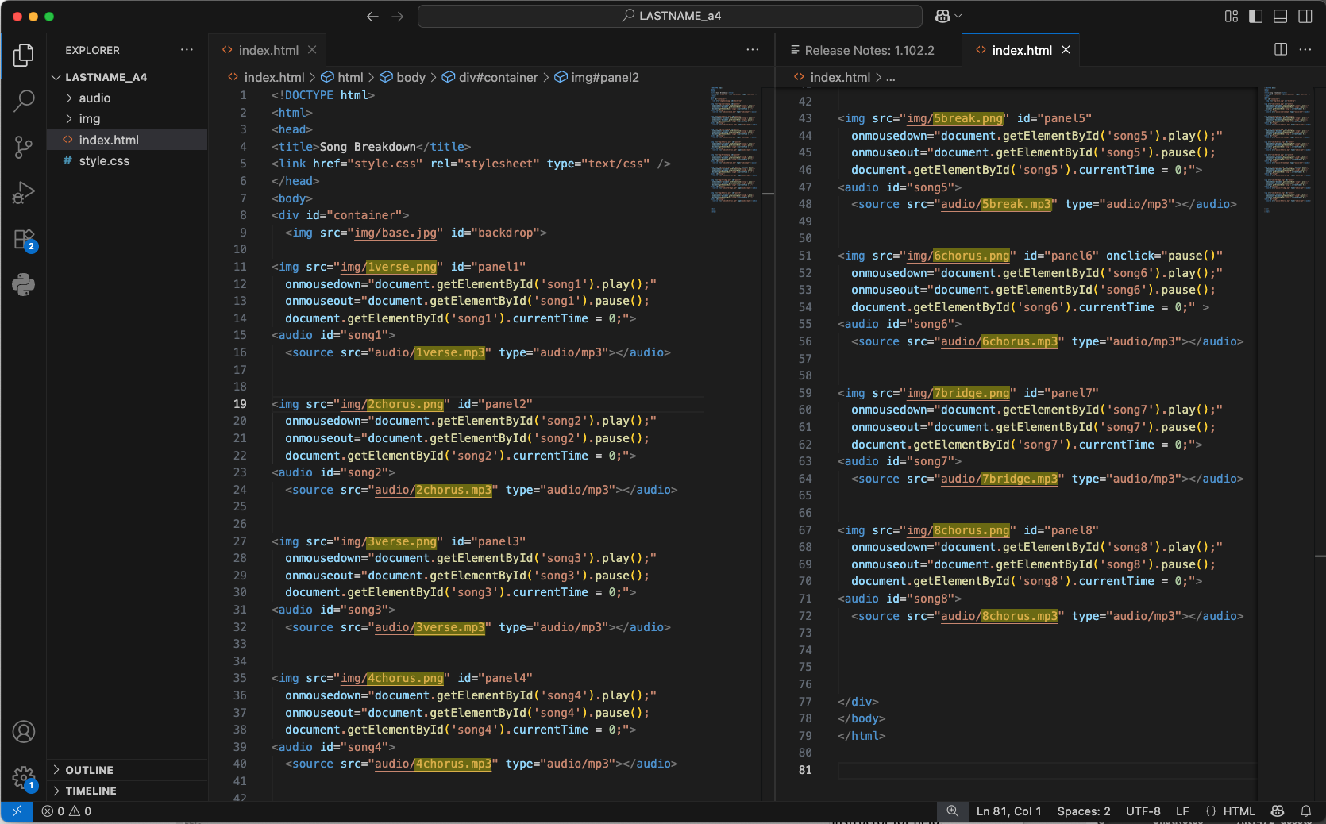

While you are typing in the code, it may not be color coded as my code is above, but once you save it as index.html, it should color code itself (excluding the yellow highlights). While your colors may not be the same as the example (since different code editing programs use their own color scheme), if the colors are not showing a pattern, there may be an error, like a left out quote mark or forward slash, for example. If you cannot figure out how to solve errors in the code, compress the entire website folder and send it to your instructor for help.

CSS code
Now that the index.html code is edited, you will also need to create a stylesheet. Create another new document and enter the code below. Then save it in the same folder as the HTML file and name it style.css. In the CSS code you do not have to replace filenames, instead, you will change the position of each image of the parts of the song. The goal is line up the images with the base.jpg image. To do this either measure the pixels in Photoshop (see video) or try the numbers that are provided and add or subtract from the number until it lines up. Each panel corresponds to the image and sound of the same number. For example, panel 4 will control 4chorus.jpg and 4chorus.mp3.

If you followed the videos and placed the waveform at the top of the image, then you should only have to change the left: code and not the top: code. Confused? Watch the video and then reach out to your instructor for assistance.

(Your code will appear as one long file, not side by side as below).

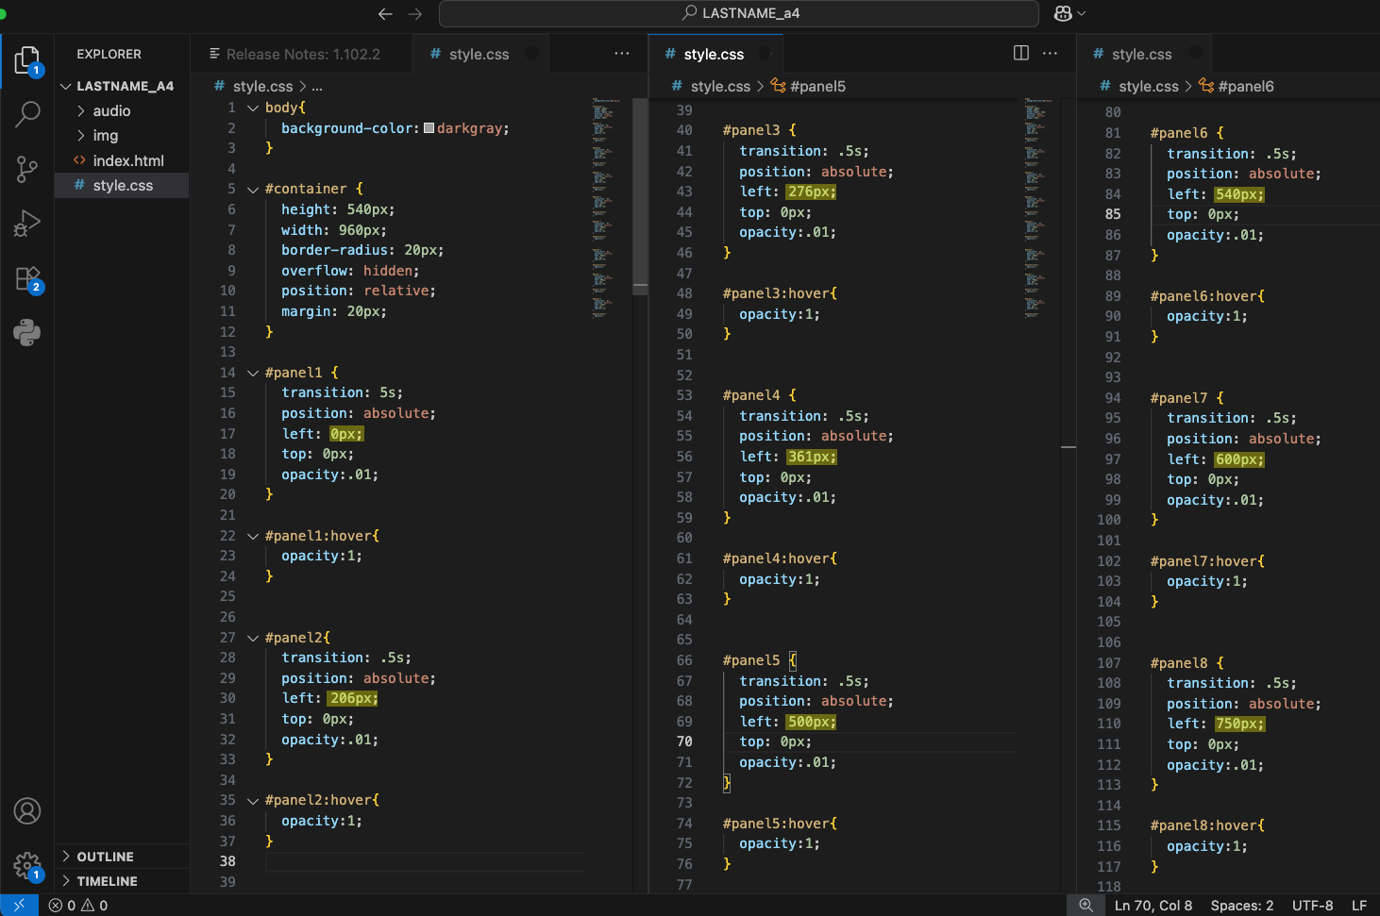

To run the code, double click on the index.html file in the web folder, and it should open in a default browser. To open it in a specific browser, drag and drop the index.html file into an open browser window. If everything goes well, the images should appear when you hover over top of them, and the audio will play when you click on them. Moving onto another section will stop the audio from playing. If it doesn't and you cannot figure it out, compress the web folder and email it to your instructor.

